**Level 0 (Context Diagram):**

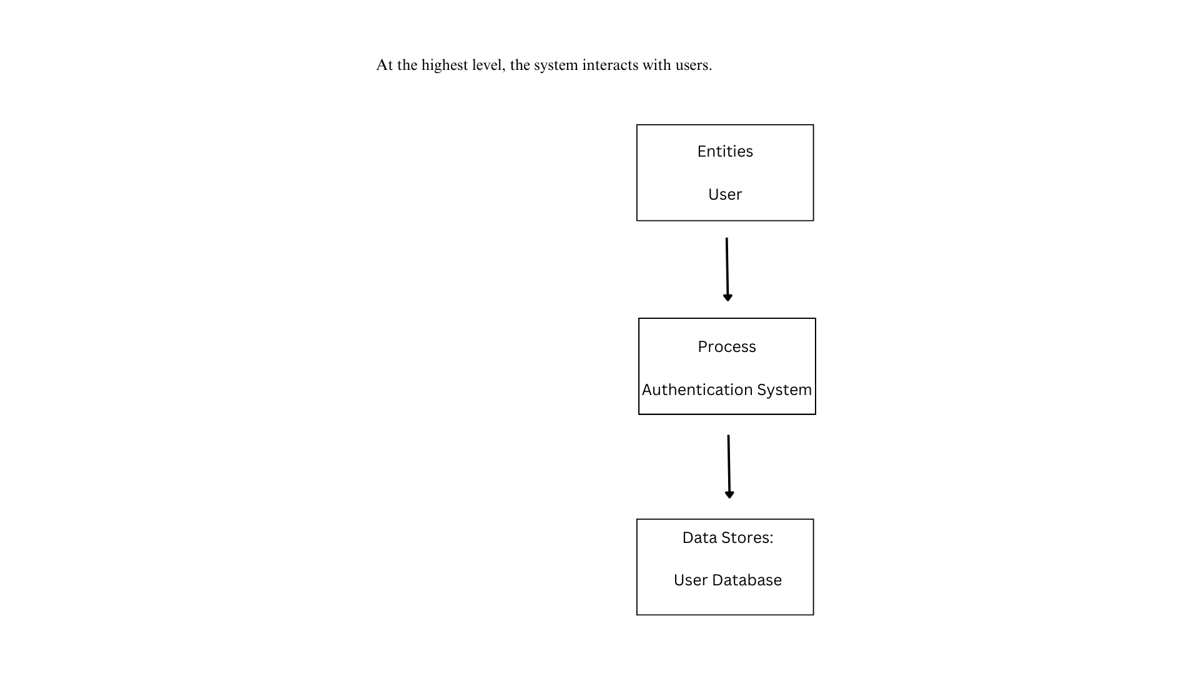

**Flow:**

1. User → Authentication System: Requests login or registration.
2. Authentication System → User Database: Verifies or stores user details.
3. User Database → Authentication System: Returns validation result.
4. Authentication System → User: Grants or denies access.

**Level 1 DFD (Detailed Breakdown)**

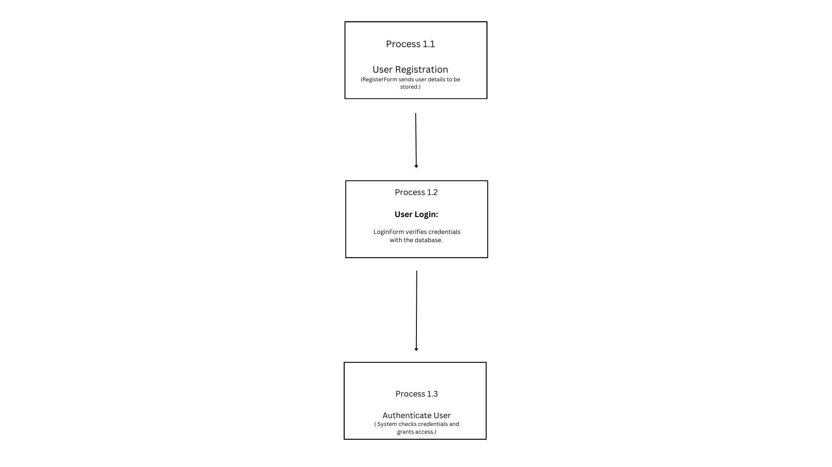

#### **Flow:**

* **User → RegisterForm:** Inputs details for a new account.
* **RegisterForm → User Database:** Stores new user details.
* **User → LoginForm:** Inputs credentials to log in.
* **LoginForm → User Database:** Verifies credentials.
* **User Database → Authentication System:** Confirms authentication.
* **Authentication System → User:** Grants or denies access.

